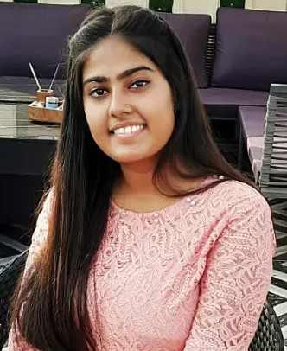hg

Phone: 9958412230

Address: RZF-768/8A 1, Gali no.8, Raj nagar part 2, Palam colony, New Delhi - 110077

Email: sonyp4355@gmail.com

**CONTACT DETAILS**

* Coding, trying new languages always.
* Singing, it refreshes my mind in work and study time.
* Traveling, I love exploring new places.

**INTERESTS**

SONi

*Want to build a professional career by working with motivated and dedicated people in a very competitive and structured organizational environment*.

• Problem Solving

• Adaptability

• Time Management

**SKILLS**

• HTML,CSS & PHP

• Python

• Poster Designing

**University of Delhi**

BA program in Computer Applications and Economics, 2021-24

Volunteer at Economics society

**Intermediate(10+2)**

Sarvodaya Kanya Vidhyalay, 2018-20

Stream- Science non medical(PCM)

Marks scored- 75.6%

**Higher Secondary (10th)**

Sarvodaya Kanya Vidhyalay

Marks scored- 75%

**EDUCATION**

I’m an undergraduate having knowledge of programming languages and web designing. Also having a good sense of humor and fast learner quality.

**PERSONAL SUMMARY**

**Internships**

**1.@YOUNITY**

Corporate Business Development intern(July 2023)

**2.Graphic designer**

Worked as graphic designer at college society.

**WORK EXPERIENCE**